Voice Training Procedure
Sample Collection
- audio_sample_collection.py (have to chuck this into the final directory)
- This script opens a microphone stream and records for 20 seconds, it is recommended the new user repeat the trigger word ("Hello World") 10 - 12 times during this period, allowing for slight pause between each sample
- Follow the instructions and guidelines in the file
- The bluetooth headset should be avaible in the selection menu, if not, make sure it is turned on, paired and connected to the lab machine
- After collecting all the necessary samples, find the file saved at the directory you specified

Sample Pre-Processing (Audacity)
- Process that file with audacity by cropping it into individual samples (e.g. if there were 12 samples in the original audio file, split them into 12 individual samples)
- Split the file from stereo to mono (mono contains the same amount of information as stereo)
- When cropping, try to crop as close to the sound pattern as possible
- After cropping, export each cropped sample as an individual wav file with the following parameters (sampling rate, sample width, number of channels)
- File – Export – Export Selected Audio… (Save as type: WAV signed 16-bit PCM)
- After this step, you should have 10-12 individual wav files with just the trigger word present
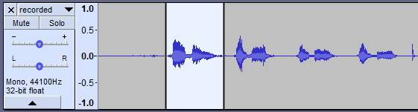
Figure 1. Example of a cropped individual sample
Sample Augmentation
- Using the HPC Bracewell for sample augmentation
- First, place all the activation phrases into one folder, download the folder containing background samples and the folder containing negative samples from ()
- Upload all three of these folders to the shared data space on Bracewell, it is suggested that you use flush1 (e.g. /flush1/IDENT/Samples).
- For more information on how to use Bracewell, visit confluence.com
- The relevant files for sample augmentation are found at confluence.com.au
- Pip3 install pydub (/home/rae025/.local/lib/python3.4/site-packages)
- There are four files in this folder:
- Job_prep.sh loads modules required to run python scripts onto HPC-Bracewell
- Sample_generator.py: the python script that performs data augmentation
- Sample_generator_HPC.py: python script that writes batch script to queue jobs, load modules and execute sample_generator.py
- td_utils.py: python script with helper functions for the sample generator
- Upload all these files onto Bracewell home directory make sure to connect over SSH File Transfer Protocol (SFTP)
- Change the file path (act_path, neg_path, back_path) in sample_generator.py so they point to the three directories where the active samples, negative samples and background samples are stored. These directories should sit on the HPC’s share data storage.
- Change the file path in sample_generator_HPC.py to point to job_prep.sh and sample_generator.py
- Additional file path that have to be specified
- execute sample_generator_HPC.py with a python3 compiler

